**Music supplement to Lute News 79 (September 2006)**

**Lute Arrangements of Music by Hans Leo Hassler (1564-1612)**

This supplement explores lute arrangements of music by Hans Leo Hassler and includes a complete listing of the seventy five intabulations for lute known to me, as well as tablature for a selection of twenty eight items to represent the wide variety of genres: intrada, canzona, dances, Latin sacred vocal music, Italian madrigals and canzonettes, as well as German lied. And this selection reveals tuneful music that fits surprisingly well on renaissance lute, although that does not mean it is easy to play!

Hassler was a German composer of mainly vocal music, born in Nürnberg in 1564 to a musical family: his father Isaac [*c*1530-1591] was an organist who taught his three sons the rudiments of music, each becoming important musicians of their time and each being enobled by Rudolf II von [Habsburg](http://en.wikipedia.org/wiki/Habsburg) [1552-1612], Holy Roman Emperor and king of Bohemia and Hungary. Hans Leo’s brothers were Kaspar [1562-1618], organist and composer in Nürnberg, and Jakob [1569-1622], organist and composer in Augsburg in the service of the catholic Fuggers, a prominent family of bankers to the Habsburgs. However, Hans was by far the most famous member of the family, as an organist, organ designer and prolific composer. In his early twenties he spent eighteen months in Venice as pupil of Andrea Gabrieli, organist at St Marks cathedral, with fellow pupil Giovanni Gabrieli, Andrea’s nephew. After his return to Germany in 1585, Hans was appointed chamber organist to Octavian II Fugger of Augsburg in 1586, gaining a royal privilege to publish music in 1591 and the title of Hassler von Roseneck with his own coat-of-arms in 1604. He has an aristocratic air in the portrait above, an engraving of 1593 by the Antwerp artist Domenicus Custos. Moritz Landgrave of Hesse tried to acquire his services as organist in 1597 but Hans was seconded to the household of Christoph Fugger in Augsburg for two years instead. He became director of the *Stadtpfeiffer* in Augsburg, but then moved to Nürnberg as director of town music in 1601 following the death of Octavian Fugger in 1600. In Nürnberg he was also appointed imperial servant at the court of Rudolf II as well as organist at the Frauenkirche. He moved to Ulm in 1604, where he married Cordula Claus, the daughter of a respected merchant family, but they had no surviving children. The final move was to Dresden in 1608 as chamber organist to Christian II, Elector of Saxony [1591-1611] as well as assuming the duties of Kapellmeister. However, he contracted tuberculosis, dying in 1612 during a visit to Frankfurt am Main to attend the coronation of Holy Roman Emperor Matthias [1557-1619].[1]

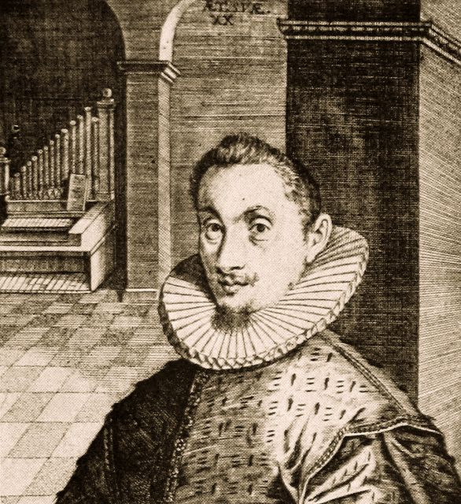

Hassler was a versatile composer, writing masses and Latin motets for the Roman church as well as Lutheran hymns; madrigals and canzonettes in the Italian style he learned in Venice, as well as German secular songs; also composing intrada, canzona and a few dances for instrumental ensemble, all genres found in his many publications (see p. 21 for title pages of most of those containing the vocal models for lute intabulations).[2] However, considering his professional role as organist, it is curious that he published no keyboard music, although a considerable body survives in manuscripts.[3] His romantic song *Mein* *G'mut ist mir verwirret* [My mind is all confused] (no 66 below) is now better known as the theme [Johann Sebastian Bach](http://www.answers.com/topic/johann-sebastian-bach) combined with the words of Gerhardt, *O Haput voll Blut und Wunde,* in the so-called passion chorale of his St. Matthew Passion.[4] Also, Hassler’s popular dance-song *All Lust und Freud* (no 49 below), was adapted by Heinrich Schütz [1585-1672] in his *Psalmen Davids* of 1619 in which form it is still used in the Protestant service.

There is no record of Hassler playing the lute and it is unlikely he arranged his own music for solo lute, although presumably lutes could have been in the instrumental ensembles for which he composed.[5] In fact one of his songs (no 70 below) begins ‘Let’s sing a fine little song, sound your instruments and lutes. Sweet music is what we need. Therefore pluck and sing’.[6] And he may have been aware that lute intabulations of his music were being made because many appear in the lute book of Michael Eijserrt from Nürnberg[7] thought to have been copied around 1600, when Hassler was in that city. The other major source of lute arrangements is Georg Leopold Fuhrmann’s *Testudo Gallo-Germanica[8]* published in 1615 also in Nürnberg. Although Fuhrmann’s print came to fruition after Hassler’s death it is possible he was collecting and arranging the music for his print before Hassler’s death. Indeed, it is conceivable that these three were acquainted.

In addition to Fuhrmann’s lute anthology, Hassler’s compositions are found in two other lute prints, Johann Emmanuel Rude’s *Flores Musicae/ Florum Musicae Liber Secundus* (Heidelberg, 1600)[9] and Adrian Denss’ *Florilegium* (Köln, 1594)[10] (see p. 21 for title pages of the lute prints). The remainder are found in a number of lute manuscripts, mostly bearing an ascription to Hassler. The sources are Karlsruhe A.678;[11] Königsberg;[12] Philip Hainhofer’s lute book;[13] Leipzig II.6.15;[14] Herdringen 9829;[15] Danzig 4022;[16] Elisabeth of Hessen/ Victor Montbuysson lute book;[17] Nürnberg 33748/I;[18] Dresden M 297;[19] Lodz M 6983;[20] and Paris 1108.[21]

**Inventory of lute intabulations of music by Hans Leo Hassler** Items edited here are numbered in bold. Minor editorial changes made without comment.

**Intrada**

**1a.** *Intrada hasler*, D-Kl 4° Mus. 108 I, f. 56v

D-Ngm M.272, ff. 12r-12v *Intrada prima. Di Jo. Leo Hassler.* [violin]

**1b.** *Intradae Hasleri primae Disc.*, LT-Va 285-MF-LXXIX, f. 34v. *Ejusde Basso*, LT-Va 285-MF-LXXIX, f. 34v [in G].

Model: Hassler 1601a,[22] no 40 *Prima Intrada*.

**2.** *Intrada 2 I. L. H.* [incomplete], D-KA A.678, f. 19r

Model: Hassler 1601a, no 41 *Seconda Intrada*.

**3.** *18 Intrada Hasleri*, D-HRD Fü 9829, ff. 19v-20r [G]

*Intrada Hasleri 3*, D-LEm II.6.15, pp. 142-143 [C]

Model:Hassler 1601a, no 42 *Terza Intrada.*

**4.** *Intrada Hasler 9*, D-LEm II.6.15, p. 148

*Ejusde Int. Hasl. Disc.*, LT-Va 285-MF-LXXIX, f. 35v [D]; *Intrata 1.* [header: *Intrata. J.L.H.1*], Fuhrmann 1615, p. 131 [D]; *Intradae Hasleri 4ta Tenor*, LT-Va 285-MF-LXXIX, f. 36v [G]; *Intrada Hasleri 4ta Bass.*, LT-Va 285-MF-LXXIX, f. 35v [A]. Model: Hassler 1601a, no 43 *Quarta Intrada*; cf. HasslerM I, pp. 6-8.[23]

5a. *CAntus Primus.* [header; *Intrata Johan. Leo Has. 6. voc. prima*], Fuhrmann 1615, p. 132 [lute I]

5b. *Cantus secundus.*, Fuhrmann 1615, p. 132 [lute II]

Model: Hassler 1601a, no 44 Q*uinta Intrada*.

**6.** *Intrata 3* [header: I*ntrata J.L.H.3.*], Fuhrmann 1615, p. 133. *Hasleri Intrad. 6 Disc.*, LT-Va 285-MF-LXXIX, f. 36r [D]; *Intradae Hasleri 6tae Dis.*, LT-Va 285-MF-LXXIX, f. 36v [D]; *Hasleri Intradae sextae Tenor*, LT-Va 285-MF-LXXIX, f. 37r [G]; *Bass. 6 Intr. Haslerj Intrada*, LT-Va 285-MF-LXXIX, f. 36r [A]. Model: Hassler 1601a, no 45 *Sexta Intrada*, cf. HasslerM I, pp. 9-10.

**7.** *Intrada Hasleri 10*, D-LEm II.6.15, p. 149

Model: not in Hassler 1601a ?

8. *Intrada Hass: NB*, LT-Va 285-MF-LXXIX, f. 35r

Untitled, LT-Va 285-MF-LXXIX, f. 41v.

Model: not in Hassler 1601a ?

**Fantasia and Canzona**[24]

**9.** *Fantasia.* [header: *Fantasia Hasleri.5.*], Fuhrmann 1615, p. 17. Model: ? cf. HasslerM I, pp. 11-13.

**10a.** *Canzon A4 H. Leo Hass.*, A-LIa 475, ff. 72v-73r

*Canzon.* [header: *Canzon Hasleri.1.*], Fuhrmann 1615, pp. 20-21; cf. HasslerM I, pp 15-21.

10b. *Canzon A4 H. Leo Hassler*, A-LIa 475, ff. 79v-80r [tone lower]. Model: ?

**11.** *Canzon A4 H. L. H.*, A-LIa 475, f. 73r. Model: ?

**12.** *Canzon H. Leo Hassler A4*, A-LIa 475, ff. 73v-74r

*Canzon.* [header: *Canzon Hasleri.3.*], Fuhrmann 1615, pp. 24-25. Model: ? cf. HasslerM I, pp 26-31.

**13.** *Canzon* [header: *Canzon Hasleri.2.*], Fuhrmann 1615, pp. 22-23. Model: ? cf. HasslerM I, pp 22-5.

**Dances**

**14.** *Gaillard J. L. H.*, D-KA A.678, f. 18v. Model: ?

**15.** *Ein guetter Tantz. Leonis Hasleri* [transposed down a 4th], PL-LZu M 6983, f. 105v. Model: ?

**Latin sacred vocal intabulations** (alphabetical)

16. *Angelus Dominj* [descendit] *H. Leo Hassler A8*,A-LIa 475, ff. 14v-15r. Model: Hassler 1591,[25] no 41.

**17.** *Ascendo* [ad patrem meum] *H.L. Hass.*, A-LIa 475, ff. 21v-22r. Model: Hassler 1591, no 26.

18. *Cantate* [Domino] *H.L.H.*, A-LIa 475, ff. 25v-26r

Model: Hassler1591, no 27.

19. *Deus deus meus H. Leo Hass.*, A-LIa 475, ff. 22v-23r

Model: Hassler 1591, no 31.

20. *Dum Complerentur* [dies pentecostes] *H. Leo Hassler A8 / Aliud*, A-LIa 475, ff. 15v-16r.

Model: Hassler 1591, no 42.

21. *M*[otete] [header: *Ecce Maria genuit nobis. 5. Vocum. Joh. Lean. Hasleri*], Fuhrmann 1615, pp. 30-31.

Model: Hassler 1601b,[26] no 11; Hassler 1612, no 14; cf. HasslerM II, pp. 45-50.

22a. *In convertendo* [dominus captivitatem zion], A-LIa 475, ff. 23v-24r. Model: Hassler 1591, no 33.

22b. *Conuerte* [domine captivitatem nostram] *2.pars*, A-LIa 475, ff. 24v-25r. Model: Hassler 1591, no 34.

23a. *Jubilate Deo H. Leo Hassler A 5*, A-LIa 475, ff. 16v-17r. Model: Hassler 1591, no 39.

23b. [Nos autem populus ejus] *Secunda pars*, A-LIa 475, ff. 17v-18r. Model: Hassler 1591, no 40.

24. *Nunc dimittis seruum tuum H.L.H.*, A-LIa 475, ff. 19v-20r; cf. *Nunc dimittis seruum*, 40032, pp. 31-32.

Model: Hassler 1591 no 25.

25. *O Altitudo* [divitiarum], A-LIa 475, ff. 83v-84r

Model: Hassler 1591, no 37.

26. *Omnes gentes H. Leo Hassler*, A-LIa 475, ff. 9v-10r

Model: Hassler 1612, no 61.

27. *Pater Noster* [qui es], A-LIa 475, f. 10v-11r

Model: Hassler 1591, no 38.

28. *Motete. 4. Voc.* [header: *Quem vidistis Pastores Joh. Leon. Hasleri.*], Fuhrmann 1615, pp. 26-27.

Model: Hassler 1601b, no 3; Hassler 1612, no 3; cf. HasslerM II, pp. 32-39.

29. *Mutete.* [header: *Qui laudet Dominum. 4. Vocum. Joh. Leon. Hasleri.*], Fuhrmann 1615, pp. 28-29.

Model: Hassler 1601b, no 10; Hassler 1612, no 10; cf. HasslerM II, pp. 40-44.

**30.** *Verbum Caro factum est H. Leo Hassler*, A-LIa 475, ff. 8v-9r; cf. *Verbum caro factum est B.C.S.W.*, D-HRD Fü 9825, f. 5v. Model: Hassler 1591, no 30.

**Italian secular vocal intabulations**

31. *92. Ochi* [= A chi] *creder deggio io à 5. Hasler V.A.*, Rude 1600 I, sigs. L4v-L5v.

Model: Hassler 1596b,[27] no 5.

**32.** *Chiara et lucente stella. Giouan Leone Hasler .4. Voc.*, D-W Guelf. 18.7 II, f. 103r. *87. Chiara e lucente stella. Hasler*, Rude 1600 I, sig. L2v. Model: Hassler 1590,[28] no 20.

**33.** *85. Chi gliochi vostri. Hasler*, Rude 1600 I, sigs. L2r-L2v. Model: Hassler 1590, no 16.

34. *5. Chi mi consola ahi-mi. Giovanni Leo Hasler*, Rude 1600 II, sig. AA3v. Model: Hassler 1590, no 7.

35. *Chi mi dimandará. à 4* [index: *Chi mi dimandará, Idem* (Haslerus)], Denss 1594, ff. 44v-45r [lute & 2 vv]

Model: Hassler 1590, no 2.

36. *Canzonet. 4. Vocum.* [header: *Chi vuol veder. J. L. H.*], Fuhrmann 1615, p. 39

Model: Hassler 1590, no 12; cf. HasslerM III, p. 80.

37. *MAdrigali* [header: *Dulcissimi ben mio. 4. Voc. Joh. Lean. Hasleri.*], Fuhrmann 1615, p. 32

Model: Hassler 1596b, no 10; cf. HasslerM III, pp. 62-65.

38. *Canzonet.* [header: *Fugendo auda*[i]*. 4. Vocum. J. L. H.*], Fuhrmann 1615, p. 40.

Model: Hassler 1590, no 23; cf. HasslerM III, pp. 82-83.

39. *86.* [H]*Or va canzona mia. Hasler*, Rude 1600 I, sig. L2v. Model: Hassler 1590, no 19.

40. *Canzonette 4. Voc.* [header: *Jo son ferito amore. Joh. Lean. Hasleri.*], Fuhrmann 1615, pp. 36-37

Model: Hassler 1590, no 9; cf. HasslerM III, pp. 76-79.

41a. *8. Lieti fiori e felicii. Giovan. Leo Hasler*, Rude 1600 II, sig. AA4v-AA5r. Model: Hassler 1596b, no 1.

41b. *9. Secondo partita. O soave contrada*. Rude 1600 II, sig. AA5r-AA5v. Model: Hassler 1596b, no 2.

42. *Mi sento ohime morie. 4. Voc. J. L. H.*, Fuhrmann 1615, p. 39. Model: Hassler 1590, no 22; cf. HasslerM III, p. 81.

43. *84. O tu che mi dai pene. Giovanni Leo Hasler*, Rude 1600 I, sigs. L1v-L2r. Model: Hassler 1590, no 11.

**44.** *Ridon di Maggio. à 4* [index: *Ridon di maggio, Haslerus*], Denss 1594, ff. 44v-45r [D, lute & 2vv]

*Ridon di Maggio,* F-Pn Rés. 1108, ff. 37v-38r; *18. Ridondi Maggio. Haslero*, Rude 1600 II, sig. BB4r [C].

Model: Hassler 1590, no 1.

**45a.** *MAdrigali* [header: *Vattene pur crudel. 6. Voc./Sex Vocum. Joh. Lean. Hasleri.*], Fuhrmann 1615, pp. 33-34. Model: Hassler 1596b, no 21; cf. HasslerM III, pp. 66-70.

45b. *Secunda Pars. La trel Sang.* [header: *2. parte. La trel sang.*], Fuhrmann 1615, p. 34-5

Model: Hassler 1596b, no 22; cf. HasslerM III, pp. 71-75.

*46. 88. Vivan sempre i pastori. Hasler*, Rude 1600 I, sigs. L2v-L3r. Model: Hassler 1590, no 24.

**German lieder** (alphabetical)

**47.** *Cantio Germanica.* [header: *Ach Fräwlein zart. Joh. L. H.*], Fuhrmann 1615, p. 41

Model: Hassler 1601a, no 1; cf. HasslerM II, pp. 51-53.

48. *Ach schatz ich thu dir klagen z. 15*, A-LIa 475, f. 55r

Model: Hassler 1596a,[29] no 15.

**49.** *Aliud Alles Lust Undt freud,* [Gagliarda], LT-Va 285-MF-LXXIX, f. 36. *Galliard. alle Lust undt freude*, LT-Va 285-MF-LXXIX, f. 21v; cf. *All mein lust und freude hab ich zu dir 17*, Leipzig II.6.15, p. 422 [C]; D-USch 130a-b, no 61 [consort]. Model: Hassler 1601a, no 15.

50. *z. 2 An einem abendt spath A4 H. Leo Hassler*, A-LIa 475, f. 96v. *II. An einem Abend spat 4 Voc. transp.* D-KA A.678, f. 1v. Model: Hassler 1596a, no 2.

51. *z. 8 Brin vnnd Zürn nur immer fort H. Leo Hassler*, A-LIa 475, f. 61v. *VIII. Brin vnd zorn*, D-KA A.678, f. 4r. Model: Hassler 1596a, no 8

**52.** *das 5. das hertz tut mir auf springen*, A-LIa 475, f. 54r [F]. *Das <herz> thut mir auf springen*, D-B 4022, f. 49r [F]; *Das Hertz thut mir. Hassler 4. Voc.*, D-W Guelf. 18.7 II, f. 102v [F]; *V. Das hertz thut mir auff springen*, D-KA A.678, f. 2v [C]. Model: Hassler 1596a, no 5.

53. *Dein Auglein klar* [leüchten] *z. 12*, A-LIa 475, f. 57r

Model: Hassler 1596a, no 12.

**54.** *Cantio Germanica.* [header: *Ein alter Greiss. Joh. L. H.*], Fuhrmann 1615, p. 44

Model: Hassler 1601a, no 2; cf. HasslerM II, pp. 58-61

55. *Falsche Lieb* [warumb mich flihest] *A. 6 H. Leo Hassler*, A-LIa 475, f. 85r. Model: Hassler 1596a, no 17.

56. *z. 19 Far hin guts liedlein A 6 H.L.H.*, A-LIa 475, f. 96r

Model: Hassler 1596a, no 19.

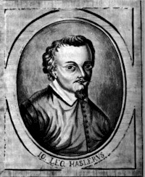

57. *A 4 Feinß Lieb du hast mich gefangen z. 4*, A-LIa 475, f. 53v.

*4. Feins lieb du hast mich gefangen 4 V. 5. trans.*; D-BAU Druck 13.4o.85, p. 83 *Feins Lieb du hast mich gefangen*; D-BAU Druck 13.4o.85, p. 85 *Feins Lieb du hast mich gefangen Hasl*; D-KA A.678, f. 2r; *8. Feines Lieb du hast mich vmbfangen*, D-LEm II.6.15, p. 417; *Deutscher Dantz vom Joh. Haßler/ Nachdantz* [*Feins lieb du hast mich gefanget*] [margin: *4 Vocum vom Haßler*], D-W Guelf. 18.8 IV, f. 10v. Model: Hassler 1596a, no 4.

58. *Frisch auff last vns ain* *Glass A 6*, A-LIa 475, f. 57v

*Frisch auf last vns* *ain* *glaß* [gutes]. *Canzone di Leonhardo Hasler à .6. Vocj*, D-W Guelf. 18.7 II, ff. 143v-144r. Model: Hassler 1596a, no 22.

**59.** *Fröllich zu sein* *z. 14*, A-LIa 475, f. 54v [F]. *Frölich zu sein In ehren. Canzone di Leonhardo Hasler à .5. Vocj*, D-W Guelf. 18.7 II, f. 144v [F]; cf. *CXI. Frölich inn allen ehren*, CH-Bu F.IX.70, p. 275; *CXXXVI. Frölich in allen Ehrenn*, and p. 285. Model: Hassler 1596a, no 14.

**60.** *Herzlieb zu dir allein Johannes Haßler .4. Vocum*, D-W Guelf. 18.7 II, f. 111v [F]. *Hertzlieb zu dir Allein z. 13*, A-LIa 475, f. 54v [F]. Model: Hassler 1596a, no 13.

61. *Ich brin* [und bin entzünt] *z. 8*, A-LIa 475, f. 58r

*VII. Ich brin 4 voc.*, D-KA A.678, f. 3v; *VII. Ich brin 4 Voc. alio modo*, D-KA A.678, f. 3v.

Model: Hassler 1596a, no 7.

62. *Canzonet. 4. Voc.* [header: *Ich habs gewagt. Joh. L. H.*], Fuhrmann 1615, pp. 42-43

Model: Hassler 1601a, no 3; cf. HasslerM II, pp. 54-57.

63. *Ich scheidt von dir* [mit leyde] *z. 16*, A-LIa 475, f. 56v

Model: Hassler 1596a, no 16.

64. *Junckfraw dein schone gestaldt z. 3*, A-LIa 475, f. 54r [F].

Untitled, D-B 4022, f. 24r; *Jungfraw dein Schoen gestalt erfrewt mich sher*, D-B 4022, f. 49r [G]; *3. Jungfraw dein schon gestalt. 4 voc. wie es stehet.*, D-KA A.678, f. 2r; *Jungfraw dein schön Vom Joh: Hasler 4. Vocum*, D-W Guelf. 18.7 II, f. 110r [G]; *Jungfraw euewr schoen Gestalt*, LT-Va 285-MF-LXXIX, f. 16r [G]; cf. *Rose e viole*, B-Br II.275 (Cavalcanti), f. 8r. Model: Hassler 1596a, no 3.

[Additional: a setting of Prinzen Tantz, 22 settings in LZtoLN130]

65. *Kein grösser freudt kan sein z. 10*, A-LIa 475, f. 55v

*X. Kein grosser freude mag sein*, D-KA A.678, f. 5r

Model: Hassler 1596a, no 10.

**66.** *Mein G'müet ist mier Verwühret Hasl. à 5*, D-Ngm 33748 I, f. 60v [B flat]

*Mein gemüth ist mir,* D-HRD Fü 9829, ff. 2v-3r [F]. *Mein gemuth,* D-HRD Fü 9829, ff. 3v-4r [F]; *Aliter*, D-Ngm 33748 I, f. 60v [C]; *Mein gemüth / Mein gemüth ex claui transposita,* D-HRD Fü 9829, ff. 4v-5r [C]; *Mein gemüt ist mihr Verriret*, D-LEm II.6.15, p. 418 [C]; *Mein gemuth ist mir*, D-Dl M 297, p. 108 [C]; *Mein gmutt*, D-Kl 4° Mus. 108 I, f. 27v [B flat]; Model: Hassler 1601a, no 24; Zahn 5385a.

67. *A 8 Mein hertz ist mir gen dir H. L. Hass.*, A-LIa 475, ff. 58v-59r. Model: Hassler 1596a, no 24.

68. *Mein lieb will mit mir kriegen H.L. Hass. A.8*, A-LIa 475, 1ff. 71v-72r. Model: Hassler 1596a, no 23.

69. *Mit danntzen jubiliern z. 18 A 6*, A-LIa 475, f. 85v. Model: Hassler 1596a, no 18.

70. *Nun fanget an ein guttes Liedlein zu singen. H.L.Hass.*, A-LIa 475, f. 53v. *Nun fanget an .4. vocum* [header: *Cantiones Hasleri 4.5.6 & 8 vocum*], D-KA A.678, f. 1r; cf. *Nu fang ein gutes liedlein zisingen*, D-LEm II.6.15, pp. 452-453. Model: Hassler 1596a, no 1.

**71.** *VI. O auffenthalt 4 Voc. 5. tr:*, D-KA A.678, f. 2v. *VI. O auffenthalt meines lebens alio modo*, D-KA A.678, f. 3r. *O auffenthaldt z. 6*, A-LIa 475, f. 58r. Model: Hassler 1596a, no 6.

72. *z. 20 Schönß Lieb du machst mir angst H. L. Hass.*, A-LIa 475, f. 86r. Model: Hassler 1596a, no 20.

73. *z. 21 Von dir kan ich nicht scheiden A 6 H. Leo Hassler*, A-LIa 475, f. 97r. Model: Hassler 1596a, no 21.

74. *Wann du jungkfraw* forthin] *z. 11*, A-LIa 475, f. 56r

Model: Hassler 1596a, no 11.

75. *Zu dir schreij ich 5 vocum z. 9*, A-LIa 475, f. 55r

*IX. Zu dir schrey Ich vmb hulff*, D-KA A.678, f. 4v

Model: Hassler 1596a, no 9.

**Appendix** [found since September 2006]

76. *Wan mein stundtlein vorhanden ist*, A-Lla 275, f. 91v; *Wan mein stündlein*, D-Lr 2000, p. 80; *Wenn mein stundlein Jacoby Reys*, D-W Guelf 18.7, f. 41v. Model: Hassler 1607, p. ?; Zahn 4482.

77. *Hasla*, D-LEm II.6.23, ff. 19v-20r & 20r cf. CLMJD no. 42 Earl of Essex Galliard. Model: Hassler 1601a, p. 15.

[D-Sl G.1.4/I, f. 35v *Chorea Chara mia dolce stella M. N.* Model: attributed to Hassler by Paul O'Dette on Melchior Neusidler CD - but it is by Regnart]

*John H Robinson, Newcastle University, January 2012*

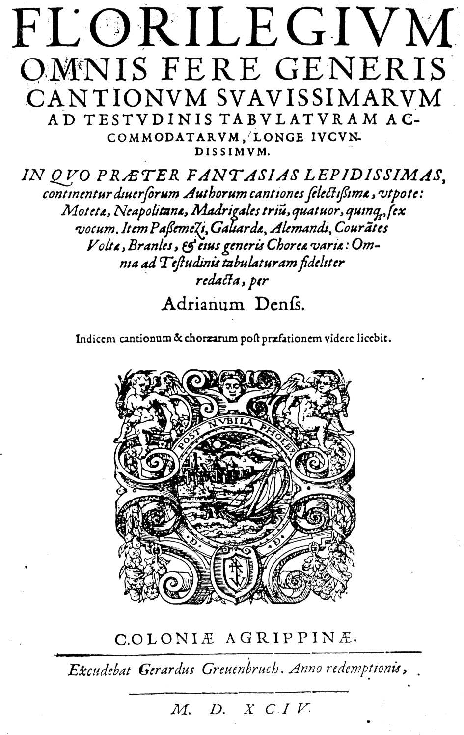

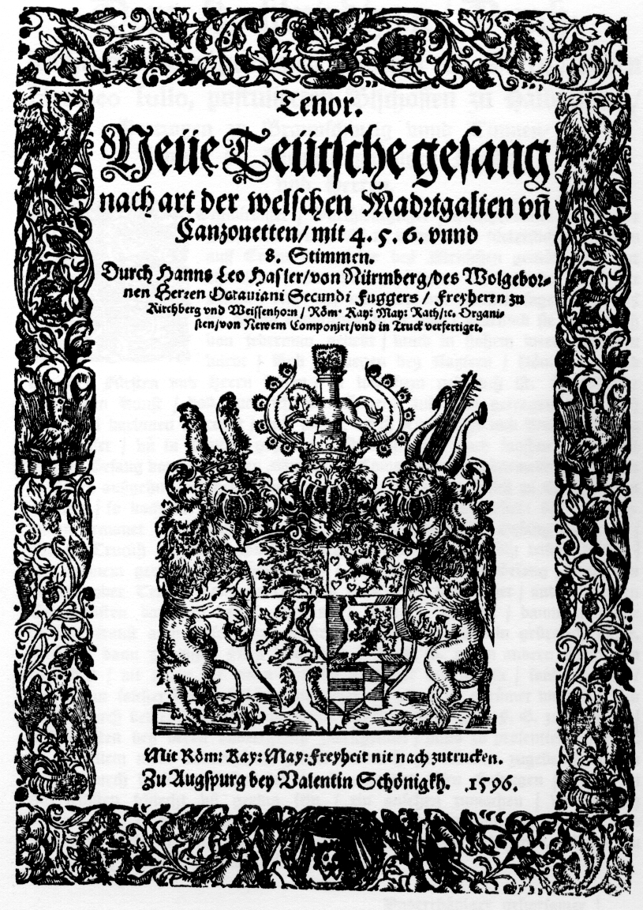

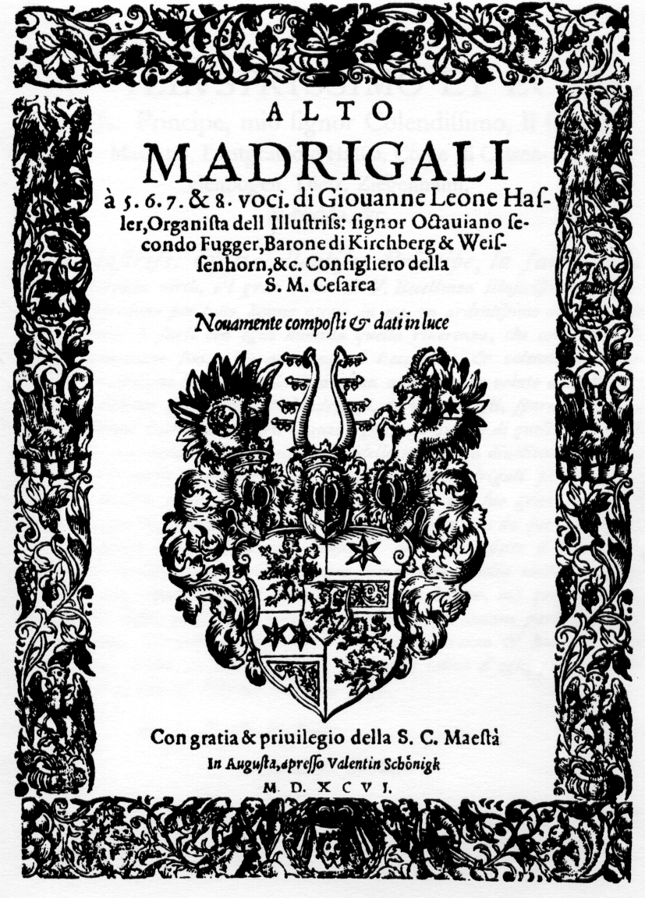

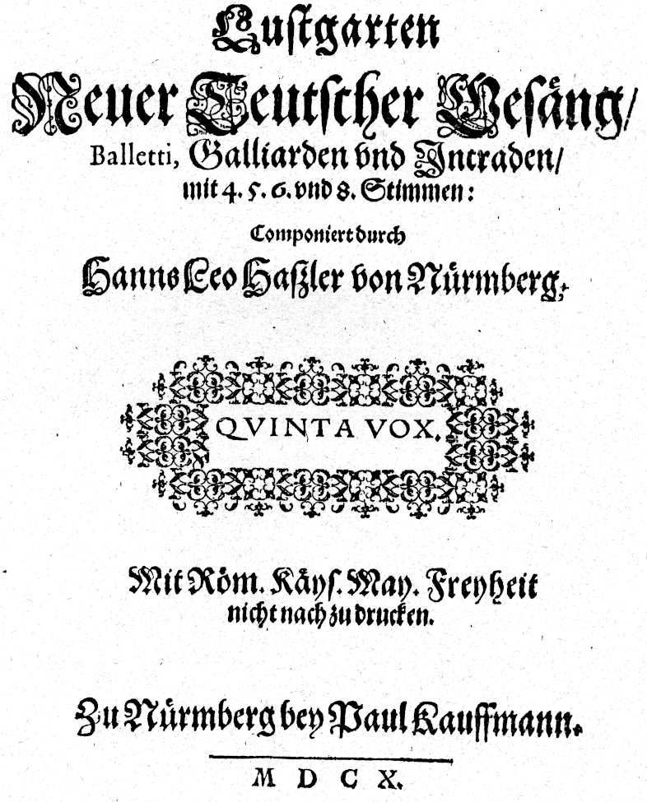

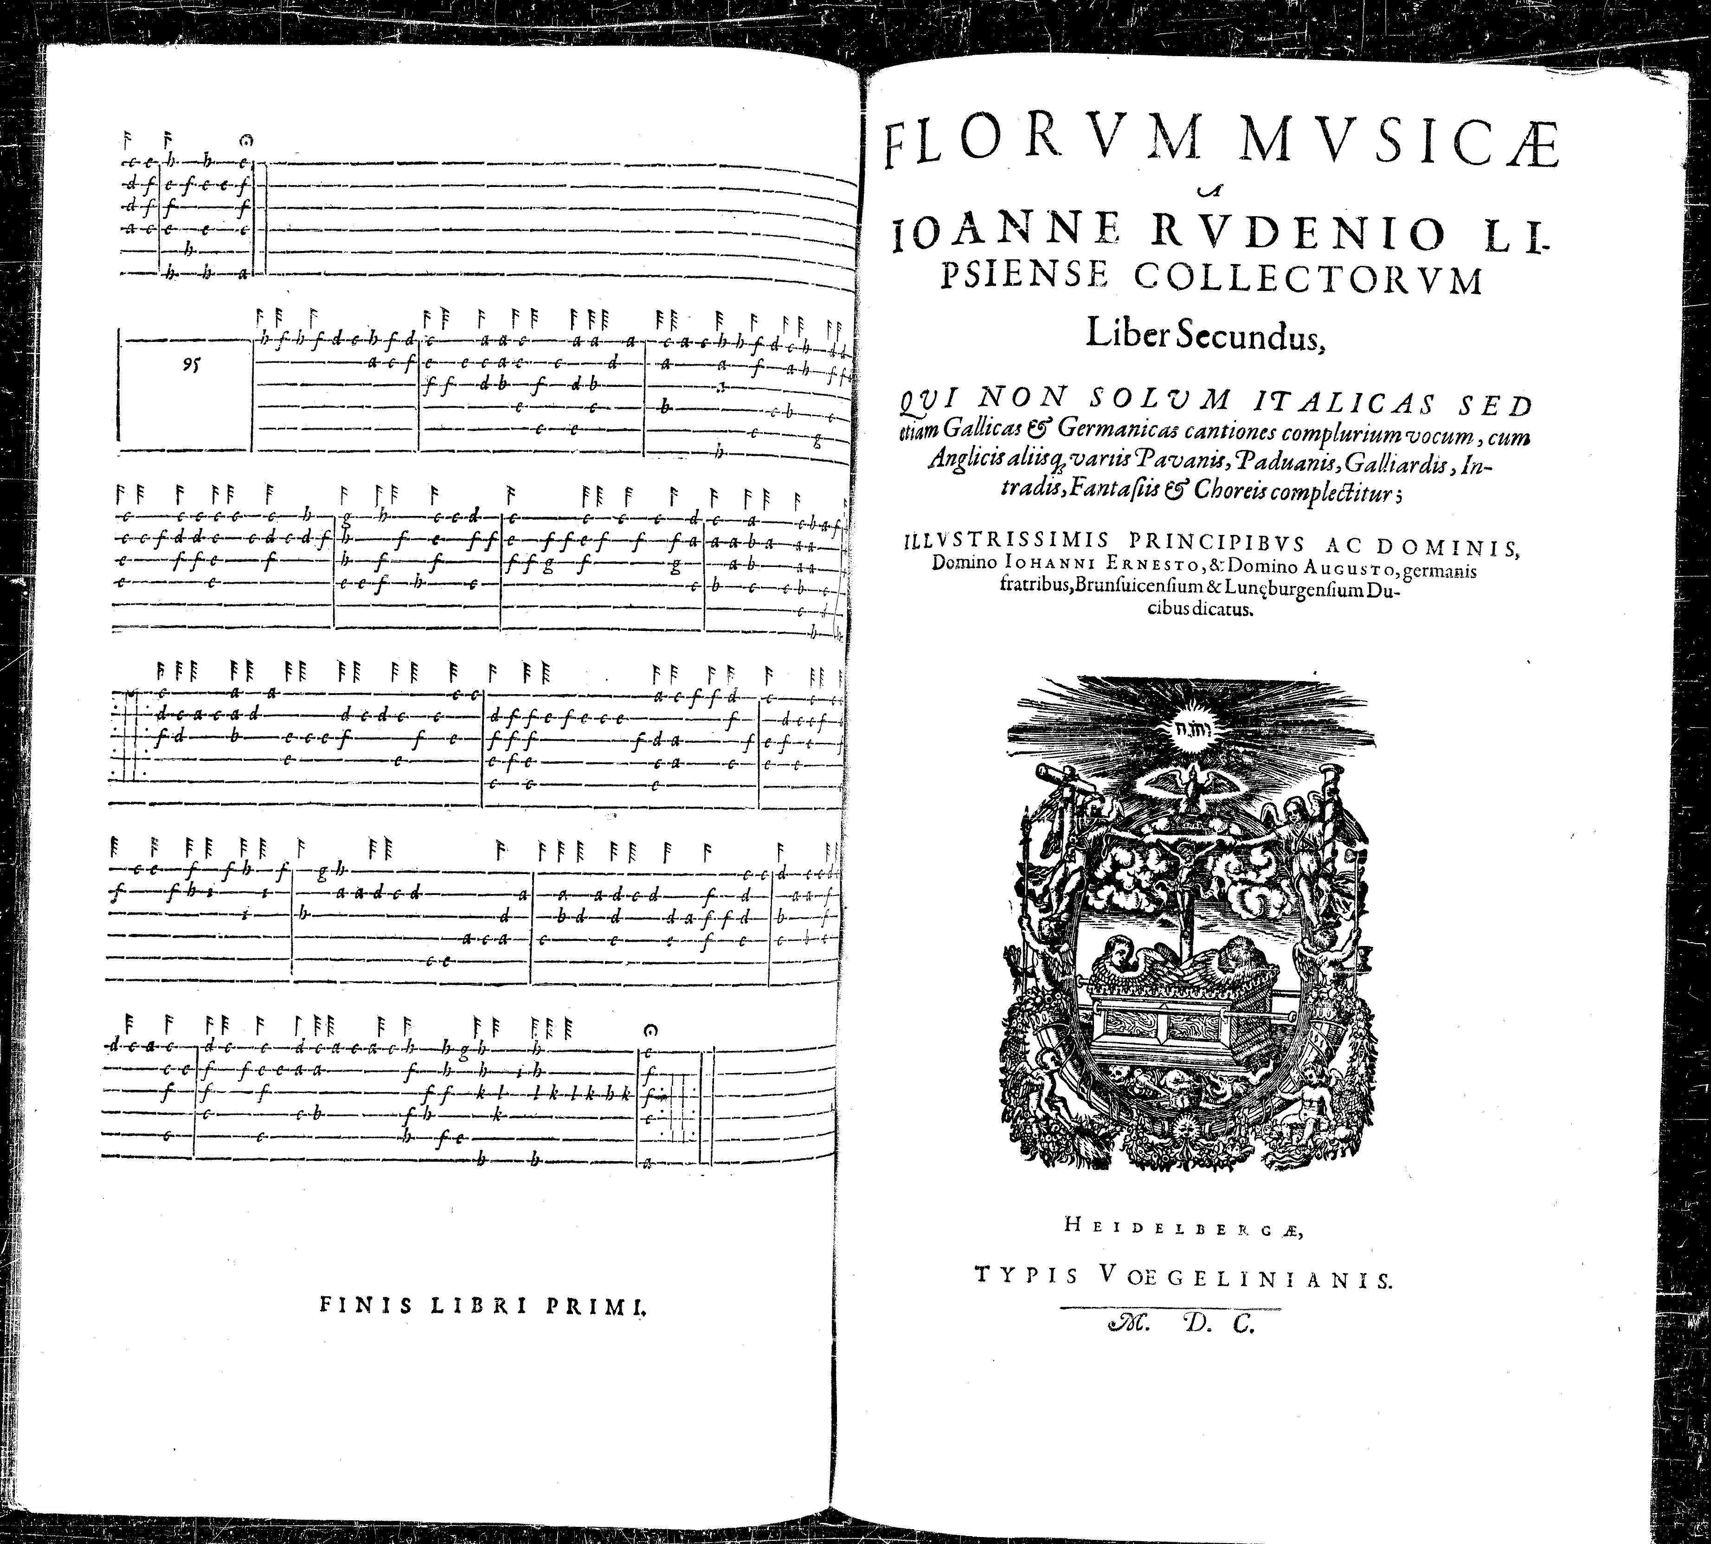

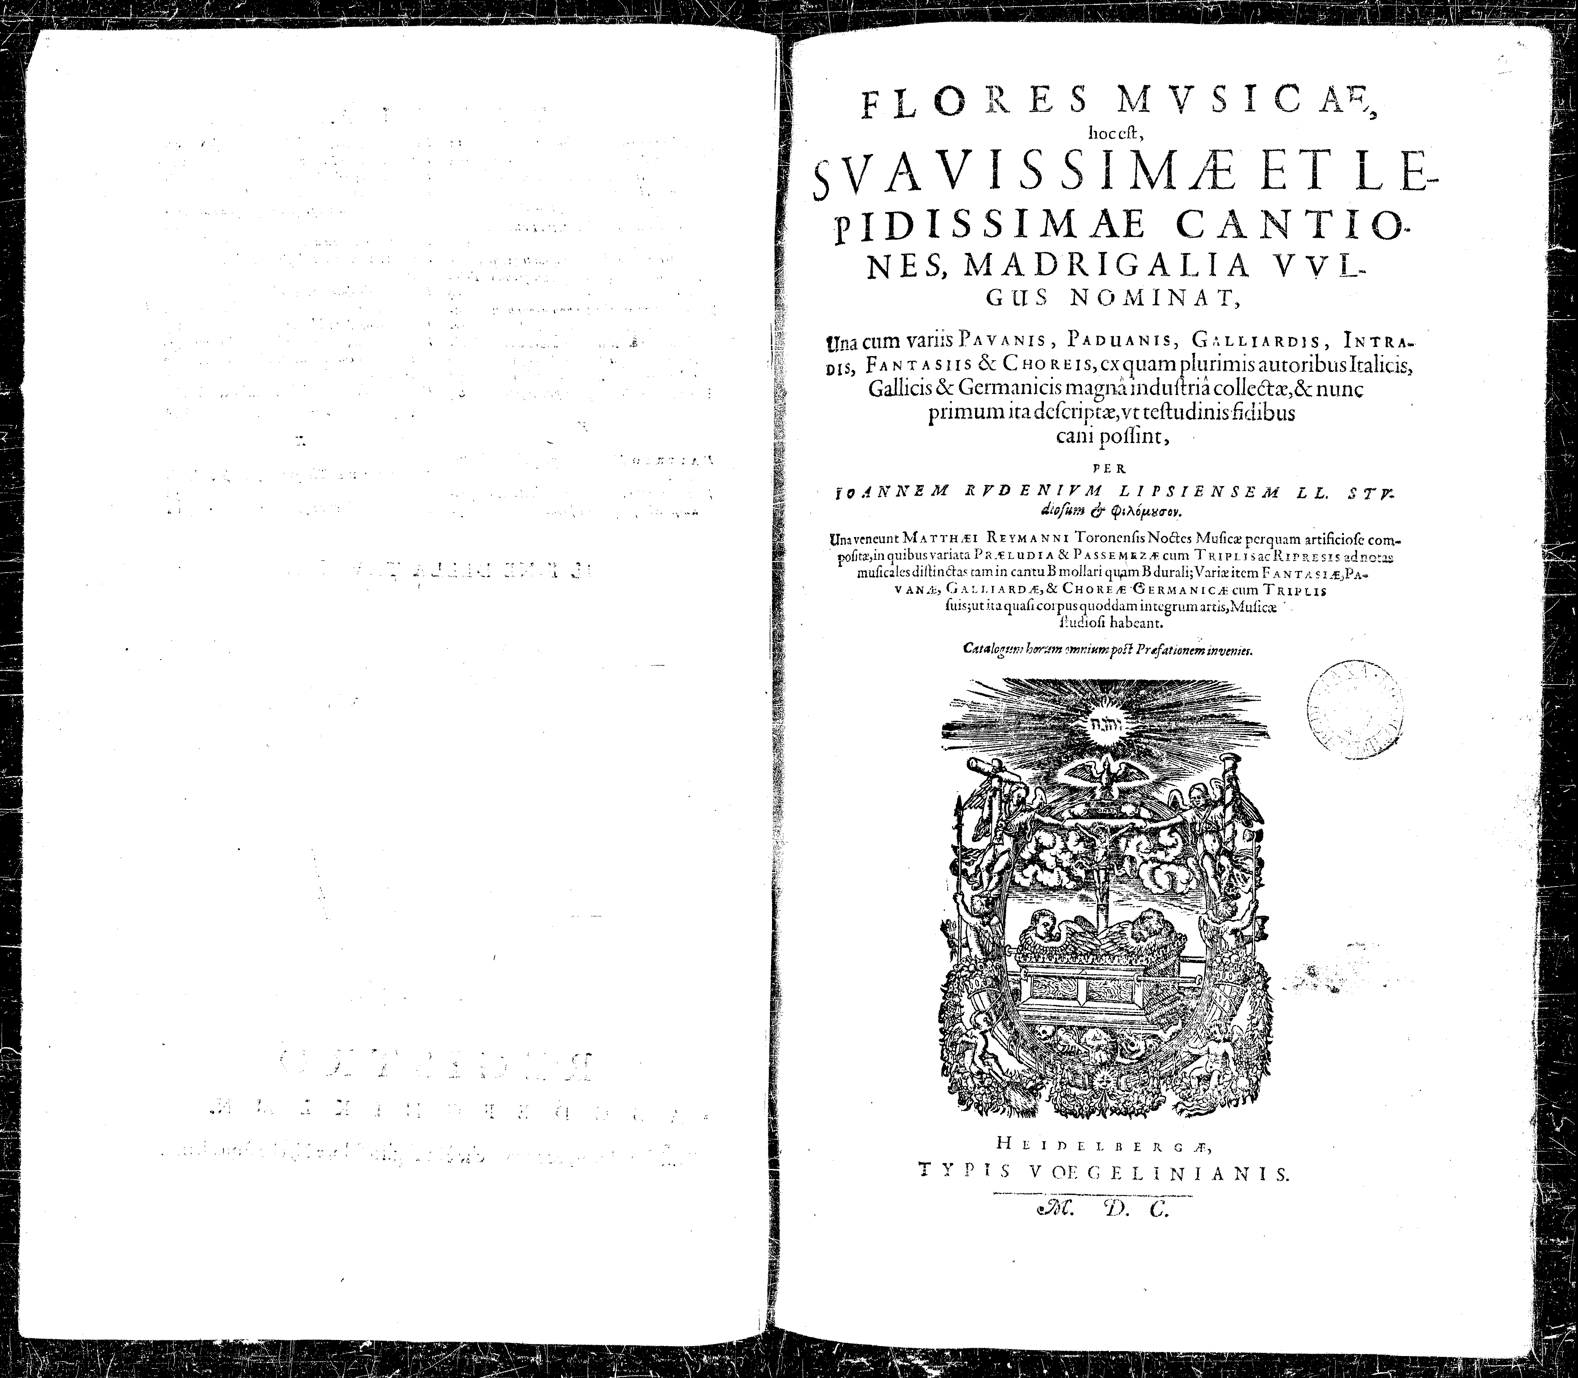

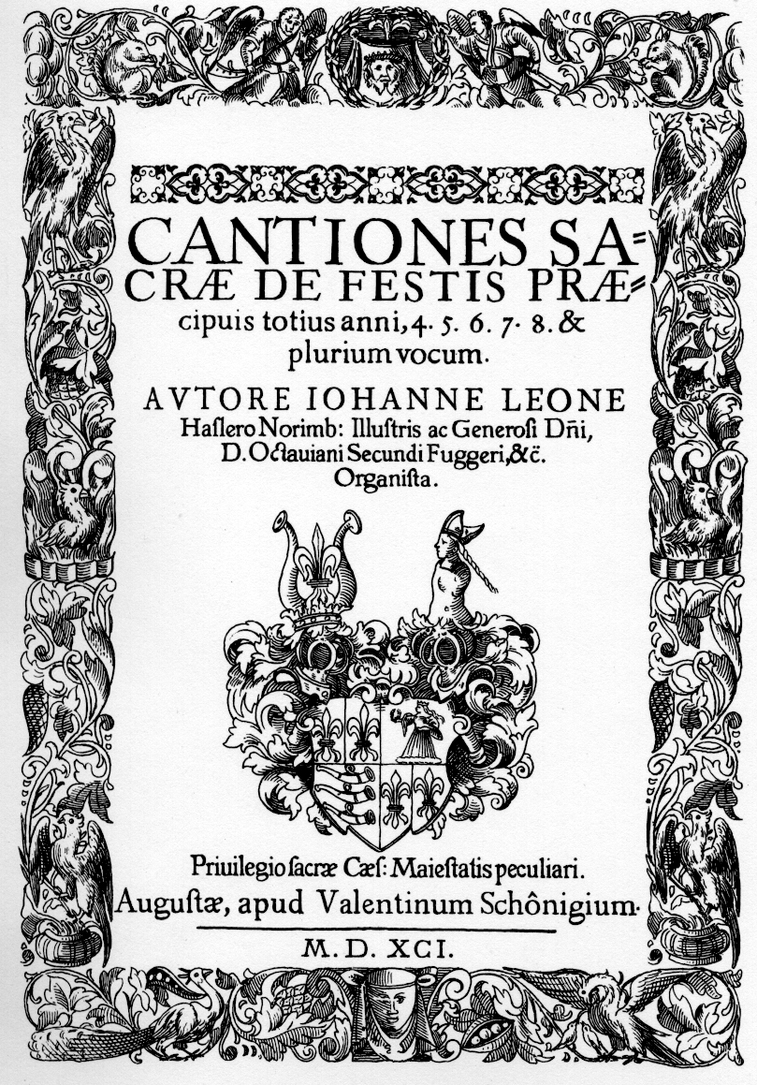

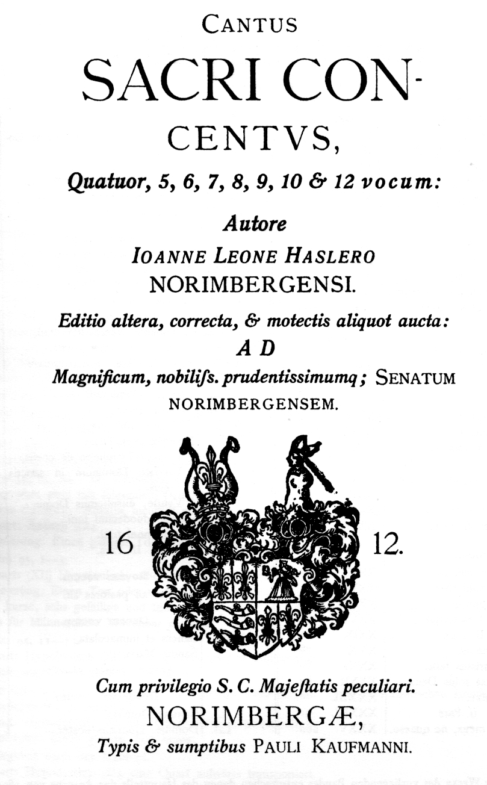

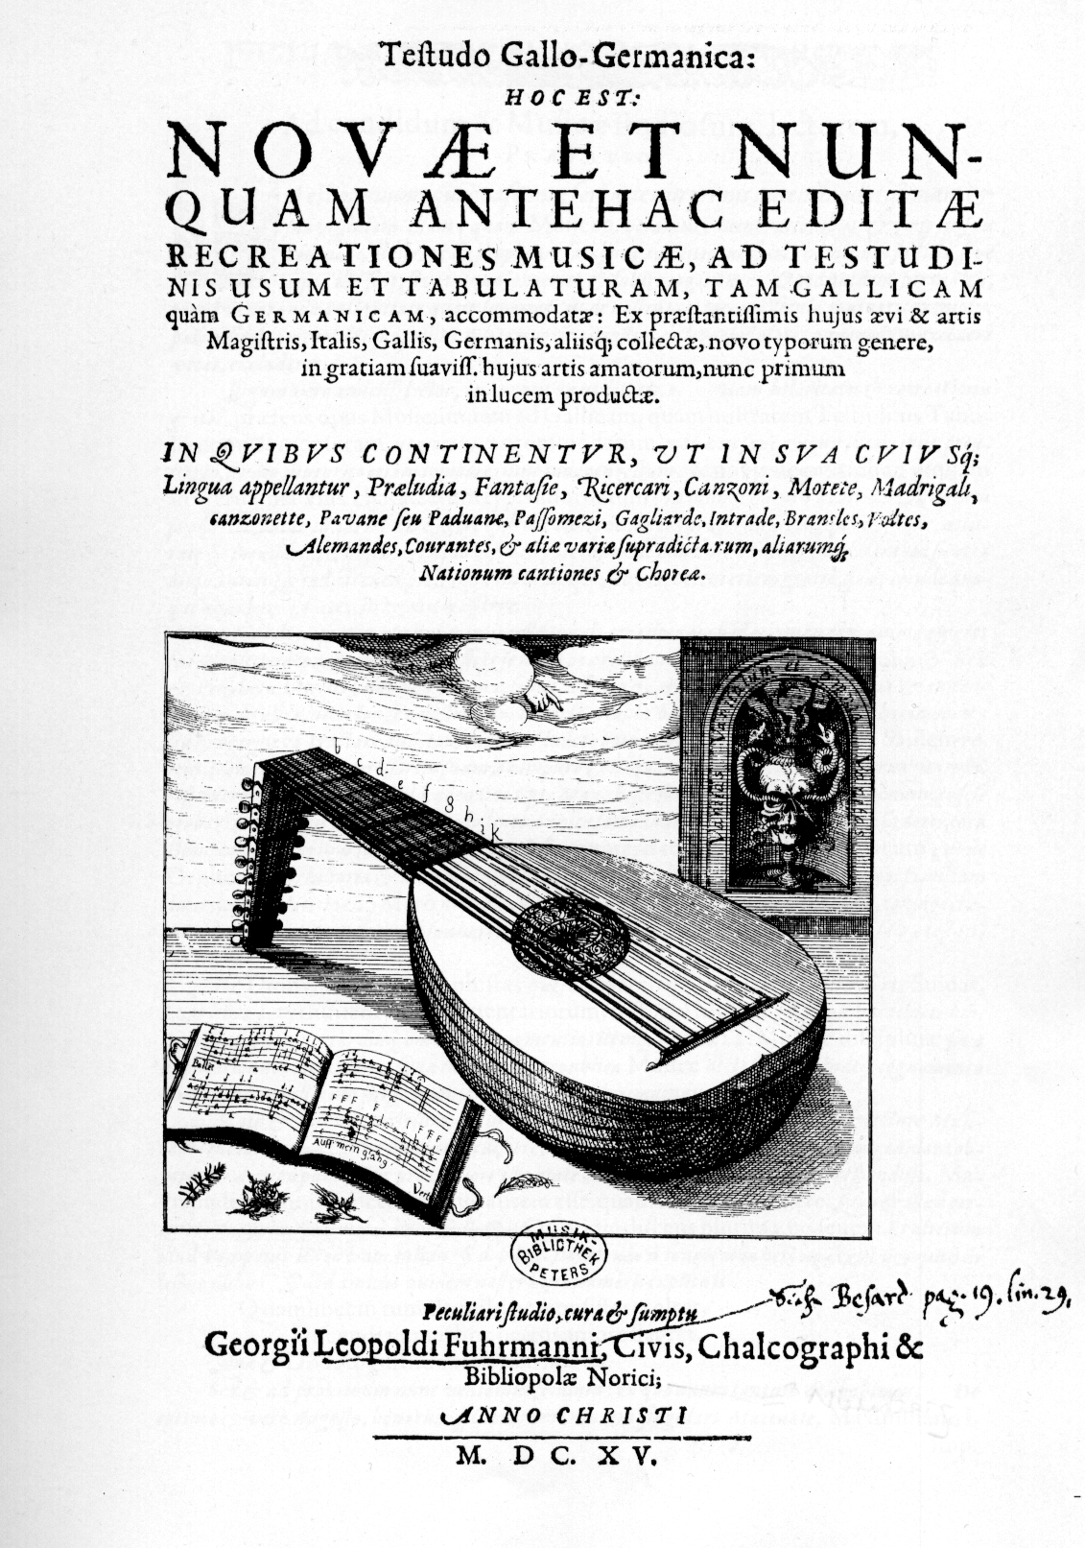

1. Walter Blankenburg and Vincent J. Panetta, ‘Hassler: (2) Hans Leo Hassler’ in Stanley Sadie, and John Tyrrell (eds.), *The New Grove Dictionary of Music and Musicians*, (London: Macmillan, 2001), vol. 11, pp. 119-126, and Google searches for Habsburg and Fugger family members.
2. See *Sämtliche Werke*, vols. I-XIII, ed. C. Russell Crosby, Jr. (Wiesbaden: Breitkopf & Hartel, 1961-8).
3. See *Sämtliche Werke*, vol. 13 I/II. Search Authors A-Z –> Hassler on http://www.breitkopf.com/home.php
4. David Greer, ‘Hassler, Hans [Johann] Leo’ in: *The Canterbury Dictionary of Hymnology*, ed. J. R. Watson (published in 2007).
5. Lutes or similar are used in modern recordings such as the CDs: *Hans Leo Hassler: Feinslieb, du hast mich gfangen: Secular Music*, Currende [Agileu Motta, lute/theorbo]/Erik van Nevel (Eufoda 1284, 1999); *Hans Leo Hassler: Cantate Domino: Motets & Organ Works*, Weser-Renaissance [Thomas Ihlenfeldt, chitarrone]/Martin Böcker/Manfred Cordes (organ) (CPO 999 723-2, 2000). However lutes are absent from the ensembles on CDs *Ich bring meim bruder ein guten trunk: Hans Leo Hassler: Madrigale & Intraden*, Städtischer Kammerchor Marktoberdorf, Jugendchor Ostallgäu/ Arthur Gross, Blechbläser-Ensemble des Consortium musicum München/ Arnold Mehl (Christophorus CHE 0074-2, 1975/1999) and *Hassler: Lustgarten Neuer Teutscher Gesäng*, Capella Lipsiensis/Diethich Knothe (Berlin Classics: Eterna 0031272BC, 1963/1993).
6. *Nun fanget an ein guts Liedlein zu singen, last Instruemnt und Lauten auch erklingen.Lieblich zu musicieren will sich jetzund gebüren. Drumb schlagt und singt.*
7. Oberösterreichisches Landesarchiv Linz [A-LIa], Hs. 475 in German tablature, *c.*1600. The vocal intabulations are interspersed with 29 English pieces including 7 by Dowland, cf. John M. Ward, ‘Appendix S. The Linz Lute Book’ *Journal of the Lute Society of America* X (1977), pp. 138-139. Includes 42 in all, 13 motets from Hassler’s *Cantiones sacrae* of 1591, 1 motet from his *Sacri Concentus* of 1601/1612, 24 songs from his *Neüe Teütsche Gesang* 1596, and three canzona, one set in two different keys, which I have not yet identified.
8. Facsimile of the copy in the Leipzig Städische Bibliotheken Musikbibliothek (Lübeck: Tree Edition, 2003). Includes 20 in all, 3 intrada, one a duet, and 3 songs from Hassler’s *Lustgarten* 1601, 3 motets from *Sacri Concentus* 1601/1612, 4 madrigals from Hassler’s *Madrigali* of 1596, and 3 canzonettes from Hassler’s *Canzonette* 1590.
9. Facsimile of the copy in the Herzog-August-Bibliothek Wolfenbüttel (Stuttgart: Cornetto, 2005). Includes 3 canzonette from *Canzonette* 1590 and 7 madrigals from *Madrigali* 1596.
10. Facsimile of the copy in the Stadt- und Universitäts-bibliothek Köln (Köln: Becker, 1994). Includes 2 canzonettes from *Canzonette* 1590.
11. Karlsruhe, Badische Landesbibliothek [D-KA], Mus. Bd. A. 678 (suppl. ms.): MS bound with copies of Ochsenkun*, Tabulaturbuch auff die Lauten* (Heidelberg, 1558), Jobin *Das Erste Buch* (Strasbourg, 1572) and Jobin *Das Ander Buch* (Strasbourg, 1573), copied *c*1596-1605. Includes 12 in all, 8 songs, 2 in two versions, from *Neüe Teütsche Gesang* 1596, an incomplete intrada from *Lustgarten* 1601 and a galliard not identified from Hassler’s prints.
12. Vilnius, Central Library of the Lithuanian Academy of Sciences [LT-Va] Ms. 285-MF-LXXIX (formerly Preussisches Staatsarchiv, Königsberg, Msc. A116. fol.): the Königsberg manuscript, *c.*1605-25. Facsimile: *The Königsberg Manuscript: A Facsimile of Manuscript 285-MF-LXXIX*, with an introduction, inventory and index by Arthur J. Ness and John M. Ward (Columbus: Editions Orphée, 1989). Includes 1 song from *Neüe Teütsche Gesang* 1596, and 12 from *Lustgarten* 1601, comprising multiple versions marked discant, tenor and bass of three intrada and one song, plus an intrada ascribed to Hassler, probably in error, that is not in *Lustgarten* but is a version of the ballad Mal Sims/La Bella Franciscina, see tablature supplement to *Lute News* 54 (June 2000), no 9, Mal Sims.
13. Herzog August Bibliothek Wolffenbüttel [D-W], Codex Guelferbytanus 18.7 and 18.8 Augusteus 2°: Philipp Hainhofer lute books, dated 1603. Includes 6 madrigals from *Madrigali* 1596 and 1 canzonette from *Canzonette* 1590.
14. Leipzig, Musikbibliothek der Stadt [D-LEm], Ms. II.6.15, dated 1619. Facsimile: Lautenbuch des Albert Dlugoraj (Lübeck: Tree Edition, 2001). Includes 3 intrada, 2 from *Lustgarten* and one unidentified, and 3 songs from *Neüe Teütsche Gesang* 1596 including *Mein Gemüth*.
15. Herdringen, Fürstlich Öttingen-Wallerstein’sche Bibliothek, Schloss Harburg [D-HRD], Mus. Ms. Fü 9829, *c.*1600-20. Includes 1 intrada from *Lustgarten* 1601 and 3 versions of *Mein gemüth* from *Neüe Teütsche Gesang* 1596.
16. Berlin, Staatsbibliothek zu Berlin, Preussischer Kulturbesitz [D-B], Musikabteilung mit Mendelssohn-Archiv, Depositum Danzig, Ms. 4022, *c.*1615-20. Includes 2 songs from *Neüe Teütsche Gesang* 1596.
17. Universitätsbibliothek - Landesbibliothek und Murhardsche Bibliothek der Stadt Kassel [D-Kl], Ms. 4° Mus. 108(1): Montbuysson lute book, *c.*1611. Facsimile Lautenbuch der Elisabeth von Hessen (Kassel: Bärenreiter, 2005). Includes 1 intrada from *Lustgarten* 1601and a version of *Mein gemüth*.
18. Nürnberg, Germanisches Nationalmuseum [D-Ngm], Ms. 33748.I, *c*1615-20. Modern edition with facsimile: *Die Tabulatur, Nürnberger Lautenbuch Handshcrifteliche Tabulaturensammlung 1600*, Teil I-V (Hofheim am Taunus: Hofmeister, 1979). Includes 2 versions of *Mein gemüth*.
19. Dresden, Sächsische Landesbibliothek [D-Dl], Handschriften-abteilung, Ms. M 297: Jena student B.K.K.S. lute book, dated 1603. Includes a version of *Mein gemüth*.
20. Biblioteka Uniwersytecka Lodz [PL-LZu], Ms. M. 6983, c.1600. Includes a tantz not identified from Hassler’s prints.
21. Bibliothèque nationale Paris [F-Pn], Rés. 1108, *c.*1610-20. Includes a canzonette from *Canzonette* 1590.
22. Hassler 1601a: *Lustgarten Neuer Teutscher Gesäng, Balletti, Gaillarden und Intraden* (Nürnberg: Kauffmann, 1601, 1605, 1610), RISM A/I/4 H 2340, 2341 & 2342. Facsimile of 1610 edition: Stuttgart: Cornetto, 1998 [A,T,5,6,7,8, not S & B]. Thirteen items from 1596a and 1601a were reprinted in Hassler & Haussmann 1615: *Venusgarten: Oder neue lustige liebliche Täntz teutscher und polnischer Art, auch Galliarden und Intraden* (Nürnberg, 161522), RISM A/I/4 H 2344. Facsimile: Stuttgart: Cornetto, 1998 [A,T,5,6,7,8, not S & B].
23. Modern edition: *Die Tabulatur, Hans Leo Hassler Lautenwerke*, Teil I-III, Helmut Mönkmeyer (ed.) (Hofheim am Taunus: Friedrich Hofmeister, 1982).
24. I have not been able to identify the four canzona, which are not amongst the four in Hassler’s prints, but may be found amongst the dozen or so keyboard canzona, the modern edition of which I have been unable to consult. The fantasia is not his only known fantasia, *Fantasia ut re mi fa sol la*, although it may be one of the 23 recercars or 10 tocatas in keyboard manuscripts.
25. Hassler 1591: *Cantiones sacrae de festis praecipuis totius anni* (Augsburg: Schönigk, 1591, enlarged Nürnberg: Kauffmann, 1597, 1607b & 1612a), RISM A/I/4 H 2323, 2324, 2325 & 2326.
26. Hassler 1601b: *Sacri concentus quatuor* (Augsburg: Schönigk, 1601), RISM A/I/4 H 2328. Hassler 1612; *Sacri concentus quatuor* (enlarged Nürnberg: Kauffmann, 1612), RISM A/I/4 H 2329.
27. Hassler 1596b: *Madrigali* (Augsburg: Schönigk, 1596), RISM A/I/4 H 2339.
28. Hassler 1590: *Canzonette a quatro voci libro primo* (Nürnberg: Gerlach, 1590), RISM A/I/4 H 2335.
29. Hassler 1596a: *Neüe Teütsche Gesang nach art der welschen Madrigalien und Canzonetten* (Augsburg: Schönigk, 1596, reissued Nürnberg: Kauffmann, 1604, 1609), RISM A/I/4 H 2336, 2337 & 2338.